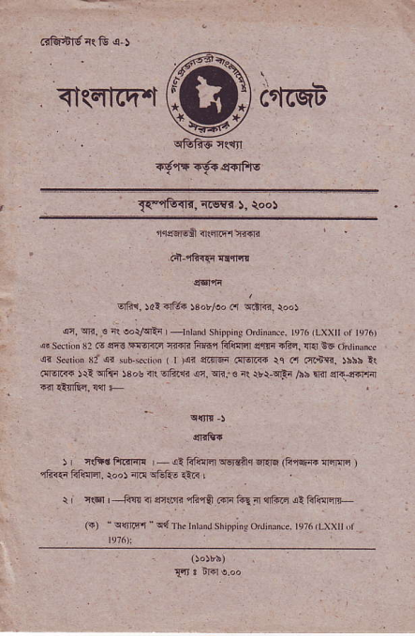
^{<|(4icq'.i}ffi
_{Ta9ft.|Ir.} r@Fr 5. aoo)
€rF ',ldi-rtr _{$otloo ir} ^{q|'ld.} r"")
an, oln, € ft sorFrii | -lnrnd
_{fimq ftliFt} ^{q.rF} .fiq, cral d6 .r,linima
<? _{sedior 31or $b *rioi} ^{( r} _{)qr} eiff6 llIF@ rc n .{.+ri. )hhb l{ {ln!@ _{)ri} ^{qRq} _{$os ft} ^{qfii6} (r. ^{qr..e} it r'r-qrF ₁₁₆ lli sq-cilllir 14!ffi,!{l +
qrrli.
r, r{idftrrft4 - _{!l tr@m} ^{qsrsir} cr.lq di,le:ffi ^{ffi} ) 1hi{i hl!!m. _{r"o)} irn offi- €.< L
r n€1 | ^{-&!q} _{{ {r{rr} ^{,iF ra rri ftr} ₁ ^{qii.E} ai ftR:lFiJL
_{(i)} ^{q$r.fl q{} i h. rtrrrmr shippi". o.r"""... n" ,Lxxrr ,,r r976):
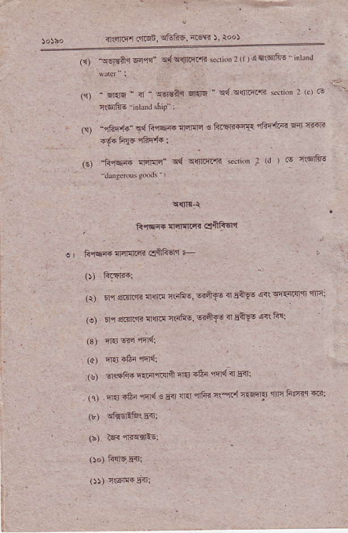
_{45R{r a.]t6n.} s5?5,4w ) rooi
_{(r)} ^{ir6r,A.l} _{Fq{"} ^{q{qq|.R'R} _{ss,i{r,} ^{(r} _{) 4x(dfi!} _ irhi'l
_{,'r} ⁻ _{m " i} ^{- qsiar} _{f,arq} ⁻ q{ sdrq'< Gri n: e'F . _{csrftE} ^{-idrxds(ip} i
' _{F'} ^{-'riF'L-} od 6lce ^{'FEn s} _{"'itBd{r} ltFlF @ &6rr -i6,tFS iffi.:
_{ilt} ^{_hffi} _{nNFr- d} ^{qq1Fl4} {di _{r: rJ} i5 tsls
f.rffi E{II.|'| clliftqr
o h6ir{ {r!.a ciSFqr +
(r) 5n srnErr arpF i5fi8. €"ft{6 <r _{nnl6} 4<rFq'{tn itF: _{te,} m siqc'i _{{@ 444q,} 6FF { _{bA-iE} r+ F!:
_{{3) qI{6$I} q'iqi
_{(s) o<tfq{} q..4rcFi E15 4lti mn d F4,
. (q) . rT4.6i rrrd € s.r € irtn r$.{ ftEnF fic Fltiq {i;
_{oo)} f{!lg5{ri
(rt r1Gre 5<r:
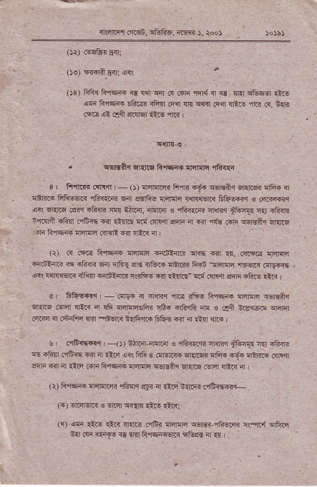
<Rrftq,j _{i'fi88,} q&1ic, ^{lriw} ), too)
_{OO} Ffr! G"1q@ n! _{r"n} ^{qir} _{@ @ n{} ^{q} _{ss {]{i} ^{qB6lr} rt@ _{iF} ^{.ai'Ee} 6FBi .io tr{ @ ^{qc} _{!G{ !ttr-,} ^{-_F} 6, t- ^{.€ al} ell €rlMJ iliE 1R L
_{;qsaq} ^{qrsd} _{ArFft 1lrlEn} qe{q
3 , Fi{6i _{.q]r.|l |} ⁻ _{O)} ^{q:n{lcri} _{F{li} 'i{. qo€Ar q{ffi qhr q ^{qltF@} _{ffi|6qc< 4i<rla} ^{qir} e!1R6 rF1lrn &r!{€iR 61i@,r € am?Frq ^{qii qr.r@} ffi"1Fj?{i n!]l +ftq. _{am.ir s rft{rrri {rqn} jft'|{{ ^{'r5} +ft.{? ^{n,1r{lnr <Fn mF<{ fil} Aftr Ed _{ffiqr} ^{qqn} _{ir {rl} ^{q:k} _{rqn} qorgfrq q|{F
:iF F,lqR lrcriFl .{ar: @ {ER a
^{,),} or@'i@
_{.raidim} ^{q} ili.ri _{sdr} ^{qfrq} er€ _{r&.i} ^{qBrn} F;E \allri 1!EF @rg{iF _{@i wiFriErtr riRqr} ^{rFJiBim} isftq -{ .!!riE" !i{ .q.qr Enn 4ftE itR
_{dr 6j*6r} ^{-.fl86} _{{ {nq} ^{,nE} ilto Rrq& _{{ril@} q€rs?q ^{qrinq} ffi !ia.{ d !& ^{:lffiiFi} _{16.} ^{qFrF} ir! € _{cj &En@} q.rqr rc a c*rrrc lrir ?rsr; 6l]&,lri SF! ai ^{;n} iirl $.+ |
^{s dtr.!@{} _{1t} darGi.irn ir € ffi<irli {nr itin1{ ?{ iftn E <.tr,rfa @ { t}.n E. ^{+.} s .re _{r{'s dFa rE6} ^{qt} {. @r ^{grF} r.r 4 _{ltrq !"ri tu'6rq nFlrq} ^{q€raaq} 6EriE .sFn rEin i I
')r ^{5.@ l4l'ffiitu{I} sF _{a ffi} :,@ rsti@r
(i) €rffi € ^{qrcl lqrn} €16 €.<
({ as €i! €.< _{{'.r- .rft llqjnq} ^{qs6-cnnin} _{r(-E l} qFirc i.r F ir1@ r€ rrir frqqi{qR *t@ 1 .r
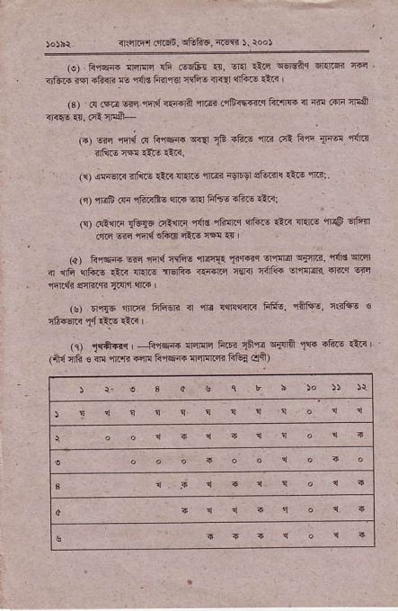
^{q$nitr} _{ftqn.} ^{q&FE,} ffi l. r.oJ
(!) Fqqe;4$i rF tqs&r er, vEr €@ ^{q6rEiq qrnr} r€ Etu i nqr _{6ftn e} ^{,r.Ird} Fm€ 4Fi6 4<{' &1|e- lnr I
(s) _{e} (qa _{ffi m{ es€'A} ^{qrm} .qtrqFnrq ft'mt ir @ cor *+it ir4.s 1r. .i? lFL
_{G) 6ir} ^{'Fn{} .! F fsc ^{wa} _{1&} 4ft! rni cl ^{fiff} _{T"@} 1{rR iinErw1it!rtR,
(1) lm.Ili 3iii€ _{itf!} ^{q{i. 'llar} iq59 ste..r{ _{1*!} 'jrF:
(r) mF aa f;r<Eu or+ cf4 Fllo +fto ?tr<:
(!) .G,nc rFg! _{.€lIF} ^{,fIlrn qhq.r} {tu! ttri _{if.rF} ^{,ll@} eF{r .,f6 w rrd EftEl dt.6 nd <{
g) li,iqFw si{mFs{i _{Tlqnq} ^{q1{lilq{'ltr.} c{r€ cnqr { ^{.nF} {fu! €.< {l.r.6 TdF{ <€?IG n€m idl'i{ en@R sFtq E-rs
($) 6l,r{5 itm liFisri n ft !{rl{{nr Ffrs. {aft! liiftG €
^{(i)} _{-rtff"rr} ---Erqe {flcrc ^{ftF} _{1aq!} ^{qillnr} _{tE} r6.s .ir< | _{cld} ^{qrd} _{! iE} ^{,lrrB} .m &.68 T{Flm FGn clft)
: :
1'
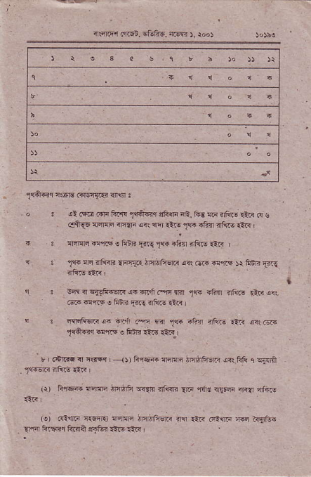
^{:n,€rrfir} _{cfr6i_} ^{qE1i6. iEln} ). rod _{)olba} '
_{1(+@} c.m iillnTFr rnrn !
. o ! il ^{cii! @ to'l{} _{t{&€q} ^{qE{F q:.} li! m rtk- _{{!ri} ^{(!} ! oftqo onrtlc rltE" r<r nI €'! _{1@} +ft{ nF,t6 €a I
i 3 lrircri dm ^{o ftdr} _{{ir!.l@} rftr {Fr@ €c
t ³ _{1@} ^{!F ?rrffi} !rnq{i. imirtutr @r G.!" d'r.$ )r ^{FEn} lr.c {w3
1 . 0w rlFri6'@ o.q.'n.s ^{nir} _{1c} $ftn rf{rs €.i !?! ^{@ @r|F o hfii} _{F!} fl',@ rtR I
! 3 trrRdaiia;Ff ^{ff Eir} _{1@} iftn flr.rE €e anl rsrF _{"fd6.r} d,RE ^{! F,iB} 1lr! e{r,
u _{.6nrqrlr$r{} ⁻¹¹ _{r} &rqd lrqrnin inj#,j?m o<t hrt c Fi'lA _{.l{i'*if@} @r
_{tr) F,r6e} ^{::ffi} ffi" w?r rili@ lEo nd! nl'ii _{rFlr} qftu l.:.n I
^{(a)} tQ'.rrn _{ftt6l5} :nffi in;Fi{.i m{ rtt" fitr @ rr!]ed rq tu6q ftrr+ ri6 ,rrd m
a!ftr ffiqi, rtu16. ffi 5. rod
⁽³⁾ i!@ i{F &!1ft. €16 € _{srnc} ^{'4rf4i?} Fr{lr !{r EftI.r
(c) ) ?ii- s ctS? li'fffi {Fr{li _{ifirn} st r 1'l!1 6€{r €tE @'rrr o ^{hiR} _{Eir-} ff:r@ di@ .in if3ii i.€ {9r 6i<n c-1.tni rftirA
_{b} ^{qsisnq} dffi 6'IrG li.rqn i']r{r<rir ! ^{eini} <G ir€- w r+rn 4inr ^{qlrr|E} .f6F? ili @ {EF 4
50 li"rqR nfq]{i d{rd .{sl ! wfgl1T6 !F!1 -E,Fe {ami rd?F ?E{.rl< ir.?' {."r .ft- t<. {<r +
nlqmq <€ ^{---6{rfEr} cli4 li{qe _{lriFF lra:tri} q€ls&q
^{qrlr} _{{F{i m} 'JaEil e rFn'i ^{?Ei{r ft ftsif<le}4-
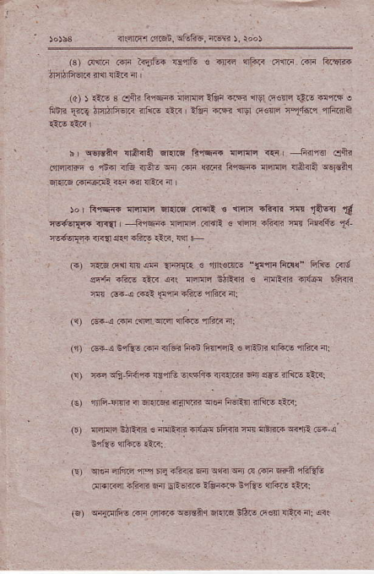
(.) _{n{rq 4qn} ^{qE} _{aa} ^{-{Fn{.r} _{e} ^{jr'nffi} "$tn1ic.<" FfrE @d _{"{ri} ^{-fe} _{€ri} et FFF _{itPe € anfnrri} ^{q{t!i} EB-n ^{w @{ @t} _{1ln} die d?R i:
⁽¹⁾ rri-! @ .@ rm ^{,iF.-} af{< 4i
^{('r)} @ i €1Es Gii irlq ftii ffi € aEnF {ftr- ilf?,< {: (i) T.r {q EFirF €,nE nnFFn iisn|4i ai sd- nErc rit<r re) nJi €.rR i 6i{@ nrni/5r sei Fi6rtn i'tu- rnF: _{.b,} ff _{Et4} (4Jm 'lm _{ffi ryfft.'} r:jaf.i
^{qri} nf'fir 1F sri.iim air _{!?ri} ^{q} F FF 6rn 6Fr6, oEir.cr _{nFfi} ^{qir} _{5-qffi} ik4@ _{t?EE} ^{q',+'iE} aarnl
w{.!rfi- @ l!i@ -@a.r Er.r,li tjhs _{iq€q} ^{qEF} a: G!
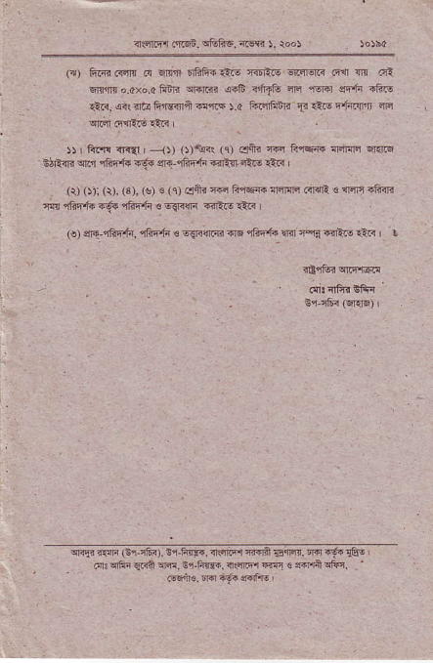
_{rl$trirl ..l.sn.} q61is, ^{r(w} ), roo!
(q) fi18 _{R4n} (r ^{qlcrft} 6rhfi.€6 {orir€ El.slqrr .4{ 1n dri m,lir o.cxo.a fillr _{sr.lrn 4-b <tr1fu s'r} ^{,llrir} sf.fi ?Ft! d.i! rn: ntt! ^{a,@e d@} ).a ^{i€;r5fti} _{F r'.&} ^{q+i.qf} f6 ^{*Fl} _{t'{..is} zttr
)r' ft.i d.d | ^{.-)r} _{rlr<irr} 'q' _{€ft} tr t'@ llr@ r.td stt _{n} ^{q.'l} _{"tFd.} ea e _{tt.-.l" €:T} .Ai- ttl!
^{(r)} _{O)i} (r). (s). (g) € (e) dtu {.s liqF. {61ni ciraR s nzrq r1i4R ^{rE} r!F,t 6-.ft-.t" €6S.F @tl.,rr-.r I
(o) _{lE-rhnfi,} ^{qEF} h ! 6{l<{l{1i rl. rfrE tu llir a-? {{tE a?< ' L _{rdr&i} qrq,ll${
Er r6<(qRF)r .:
^{qFri} r.!F (Br,itu). ir Fm, iqiqr ^{r.qa} _{srEl} ^{bra} {a _{rfu} ' €r rni qrrr _{fi. srri@,} ^{q..F qq} " rqa ^{sF. '} .@ir€.n rff{erfts

